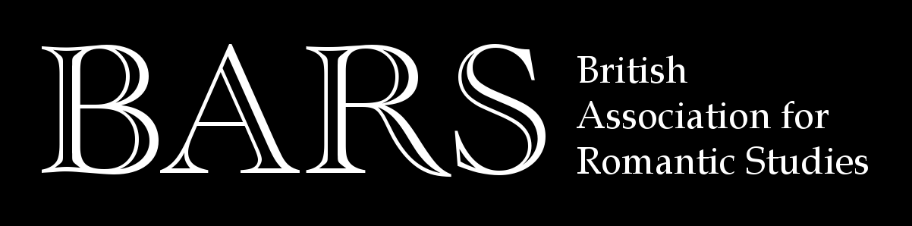

President’s Report for 2018
I am delighted to be President of BARS at such an exciting time. We are a very busy and resourceful organisation, striving to fulfil our mission of promoting Romantic studies in the UK and beyond. Our financial situation is healthy which means we can support and expand existing initiatives and develop new methods of supporting our membership. Since I became President in 2015, we have made a big push to support Early Career scholars as we recognise that this can be a difficult stage in the career path. We have therefore introduced three new awards: the Wordsworth Trust Fellowships, the Nineteenth Century Matters Fellowship (in association with BAVS), and the Scottish Romanticism Research award. I would like to expand these schemes and introduce new ones, perhaps in new national or regional centres, and/or focused on public engagement and impact, and/or linking up with international partners. I invite all members to submit ideas for new awards with clearly defined outcomes that will benefit the holders: please send ideas to the Executive via the BARS Secretary (email address on the BARS website).
Another major new development is the launch of ERA, European Romanticisms in Association. We are proud to have been a driving force behind this network, particularly in light of Brexit. I am delighted to report that ERA has been awarded a Network grant by the Arts and Humanities Research Council for a two-year programme of events (2018-20) entitled ‘Dreaming Europe’ (http://www.euromanticism.org). ERA currently hosts a BARS European Engagement Fellow and there are plans for this to continue. Congratulations to BARS Past President Nicola Watson (Open University) and her team.
Our international biennial conference in 2017, ‘Romantic Improvement’, was held at York University’s Centre for Eighteenth Century Studies and it was a great success; my thanks to the local team, in particular Jim Watt, Jon Mee and Catriona Kennedy. The next conference, ‘Romantic Facts and Fantasies’, will be held at the University of Nottingham in 2019. I am delighted to announce that the 2021 conference will be jointly organised with the North American Society for the Study of Romanticism (NASSR) and will be at Edge Hill University, Liverpool.
At the York conference, the BARS First Book Prize was awarded to Julia Carlson (Cincinnati) for her monograph, Romantic Marks and Measures (University of Pennsylvania Press, 2016). I want to thank Professor Nigel Leask (Glasgow) for his sterling work as Chair of the sub-committee for 2015-17. We are delighted that the new Chair for 2017-19 is Professor Claire Connolly (University College Cork). The next round of the book prize will begin soon: if you wish to nominate a book, please contact Professor Connolly: claireconnolly@ucc.ie.
I have tried to ensure that all members of the Executive have a specific role which they have been asked to develop with allocated resources. This model seems to be working well and the total number of Executive members (elected and co-opted) is at a record high, a reflection of the amount of activity we are generating. I have increased the budget for our current schemes: the Copley bursaries, the regular subventions for conferences, and the BARS First Book award. The ECR conference continues to be a great success. This year it will be held in Glasgow, 15-16 June: the topic is ‘Romantic Exchanges’.
Thanks to Professor Anthony Mandal (Cardiff), we now have BARS postcards, to be used for publicity purposes (all members are welcome to a bunch! Please contact the Secretary).
These achievements would not have been possible without the commitment and enthusiasm of the BARS Executive Committee (see the website for full list). I want to pay particular tribute to members who have recently left or will soon be leaving the committee. Dr Susan Valladares (Oxford), formerly the editor of the BARS Review, stepped down in 2017 after several years of dedicated and meticulous work. We are very pleased that Professor Mark Sandy (Durham) has taken her place. Dr Helen Stark (University College London) is stepping down as Secretary after doing this job outstandingly well since 2013; Helen’s place will be taken by Dr Jennifer Orr (Newcastle); again, we are delighted to welcome this new colleague.
Finally, I would like to report another BARS success: one of our nominees for the 2021 REF (Research Excellence Framework), Professor Simon Kövesi (Oxford Brookes), has been appointed as an assessor for the English literature panel. We wish Simon all the best in this important role and we are delighted that Romanticism has a voice on the panel.
I look forward to another year of exciting and productive work.
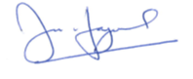
Ian Haywood, University of Roehampton
March 2018

