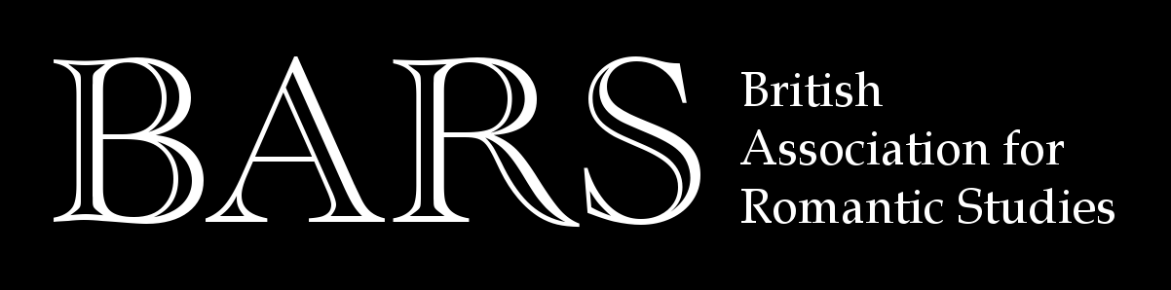

Call for Papers

Romantic Exchanges, 1760-1840

British Association for Romantic Studies Early Career and Postgraduate Conference

University of Glasgow, 15–16 June 2018

Keynote Speakers:
Professor Gerard Carruthers (University of Glasgow)
Dr Susan Manly (University of St Andrews)

The BARS Early Career and Postgraduate Conference will explore the concept of exchange in Romantic-period literature and thought. It will bring together postgraduate and early-career researchers whose work addresses this idea from a wide range of perspectives: from the economic exchange of objects and commodities, to the transnational circulation of books and ideas, to neglected connections between writers, texts and contexts.

We invite proposals for themed panels, as well as proposals for the traditional individual twenty-minute paper. Applicants might choose to address some of the following, though we also encourage you to interpret the theme more widely:

- Commercial exchange: trade, commodities, the literary marketplace, economic value.
- Epistolary exchange: letters, correspondence, bills of exchange, legal documents.
- Financial exchange: money, gifts, credit, indebtedness, political economy.
- Historical exchange: transmission and reception of writers and works across generations.
- Intellectual exchange: literary networks and coteries, periodicals and print culture, public opinion.
- International exchange: travel, intercultural encounters, translation, transnational circulation.
- Interpersonal exchange: influence, collaboration and conversation between writers.

Please send abstracts of up to 250 words for individual papers or 750 words for themed three-person panels (including name and institutional affiliation of all proposed speakers) to bars.postgrads@gmail.com by 9 March 2018.

Follow us on Twitter @BARS_PGs

Organisers: Honor Rieley (Glasgow) and Paul Stephens (Oxford)

